**Mod Development Links Compilation - Some links do not work / Formatting broken**

[[https://s2.googleusercontent.com/s2/favicons?domain=forum.kerbalspaceprogram.com](https://forum.kerbalspaceprogram.com/index.php?/topic/85372-mod-development-links-compilation-some-links-do-not-work-formatting-broken/)**forum.kerbalspaceprogram.com**/index.php](https://forum.kerbalspaceprogram.com/index.php?/topic/85372-mod-development-links-compilation-some-links-do-not-work-formatting-broken/)

**Here you will find all the necessary tools as well as tutorials, guides and snippets of info relevant to KSP modding.**

**If you come across any information that you think should be added to this thread please post a reply here.**

**Before you start:**

**1. Please visit the**[**General Add-on Affairs**](https://forum.kerbalspaceprogram.com/forums/19)**forum and check out member requests. It's better if you make something that people actually want.**

**2. Read all links marked as "Important"**

**================  
Table of Contents  
================**

**1. List of Free and Open Source Tools**  
1.1 Modding Tools  
1.2 Other Tools

**2. Not-So-Free Tools**

**3. Modding Reference Material**

**4. Modding Information Links**  
4.1 Common Problems and Solutions  
4.2 General Information  
4.3 Modelling  
4.4 Texturing  
4.5 Licensing  
4.6 Video Tutorials  
4.7 Text Tutorials  
4.8 Miscellaneous  
4.9 Unity/Configs  
4.10 Addons For Modders  
4.11 Plugin Development

**===============================  
List of Free and Open Source Tools  
===============================**

**MODDING TOOLS**

[**Unity**](https://unity3d.com/) - Game engine

This is where you rig, animate, and otherwise set up and compile the part files.

Important - YOU MUST USE UNITY 4.2.2 or earlier. Newer Unity versions do not support legacy animation which are still used by KSP.Part tools:

0.23 Part Tools

[thread](https://forum.kerbalspaceprogram.com/threads/65356?p=1878643&viewfull=1#post1878643)

**Other**

[FloatCurve Editor](https://forum.kerbalspaceprogram.com/threads/83246)

- A unity package for visualising and designing FloatCurves for your configuration files. Also read the

[KSP floatCurves guide](https://forum.kerbalspaceprogram.com/threads/93332)

[MBM to PNG texture converter](https://forum.kerbalspaceprogram.com/threads/47068)

- Unity script. Can convert whole folders including subfolders

I recommend you read the 0.23 and 0.20 Part Tools posts by Mu, they are very informative.

If you're having trouble unzipping on a Mac, [look here](https://forum.kerbalspaceprogram.com/threads/25040?p=327092&viewfull=1#post327092).

[**Blender**](https://www.blender.org/) - Full featured 3D editor.

Used for creating the 3D assets and animating. Can also be used for texturing, rendering stills and video.

**Blender Plugins:**

[**Taniwha's mu Import/Export**](https://forum.kerbalspaceprogram.com/threads/43513)

[**MultiEdit**](http://www.blenderartists.org/forum/showthread.php?339369)

- Allows you to edit a group of separate objects as a single object. Very useful for unwrapping multiple models on a single texture.

[**KSPBlender**](https://forum.kerbalspaceprogram.com/threads/111483)

- Blender addon for importing .craft files.

**Blender Bundled Plugins:**

You might need to enable these in Preferences.

**Print3D**

- Calculates volume (useful for judging resource capacity) and surface area of mesh objects, as well as does other things useful if you're making models for 3D printing.

[**GIMP**](https://www.gimp.org/) - Raster graphics editor

The best free program for creating textures and other graphics.

**GIMP Plugins:**

[**NormalMap plugin**](http://registry.gimp.org/node/69)

- Generate normal maps from greyscale bump maps.

[**Krita**](https://krita.org/) - Raster graphics editor

Includes some very useful tools not found in GIMP. Check out the [features page](https://krita.org/features/highlights/)

.**[MaPZone](http://www.mapzoneeditor.com/" \t "_blank)** - Procedural texture generator

Very powerful texture generator with a compositing interface

[**DDS4KSP**](https://forum.kerbalspaceprogram.com/threads/98672) - KSP to DDS texture converter

Use this to allow KSP to load textures faster.

[**Inkscape**](https://www.inkscape.org/) - Vector graphics editor

UV layouts exported from Blender can be edited with this. It's also useful as a secondary program for textures if you need to create precision curves.

[**xNormal**](http://www.xnormal.net/) - Texture generator

You can generate normals maps, and various masks for your textures.

[**NVidia Melody**](https://www.nvidia.com/object/melody_home.html) - Normal map baking program

Bake normal maps from high-poly models.

[**NormalMap-Online**](https://cpetry.github.io/NormalMap-Online/)

Online tool for generating Normal, Displacement, Ambient Occlusion and Specular maps

[**Meshlab**](http://meshlab.sourceforge.net/) - Mesh editor

You can use this to convert various mesh types.

[**Notepad++**](https://notepad-plus-plus.org/) - Text editor

Use this for editing configuration files. Change language to python to identify bracket pairs and collapse/extend modules.

[**Hexplorer**](https://sourceforge.net/projects/hexplorer/) - Hex editor

You can use this to spec the components of compiled mu files.

**DO NOT EDIT FILES**

unless you know what you're doing.

**OTHER TOOLS**

[**Open Broadcaster Software**](https://obsproject.com/)- Video capture / Streaming

Self explanatory. You can use it to showcase your mod.

[**Lightworks**](http://www.lwks.com/) - Full featured video editing program

Edit and add effects to your videos. Requires registration, however it really is the best free editor out there.

**================  
Not-So-Free Tools  
================**

[**Quixel dDo**](http://quixel.se/ddo) - Procedural texture generator that adapts to the shape of your model.

The old legacy version is free but it requires Photoshop, which is not free. Link is at the bottom. [Direct link](http://quixel.se/dDo/dDo_release.zip)

**========================  
Modding Reference Material  
========================**

[Blender Model Donation](https://forum.kerbalspaceprogram.com/threads/95438) - Donate or download unused models started by other forum members.

[NASA 3D Resources](http://nasa3d.arc.nasa.gov/images) - Copyright-free models and textures. **Important.** The models are too high poly to use directly.

[Linear aerospike](https://imgur.com/a/Ve9t0)

[MiG-105 Spiral photos](https://forum.kerbalspaceprogram.com/threads/113658)

[Dragon RCS in action](https://forum.kerbalspaceprogram.com/threads/95418)

[Kennedy Space Center](https://forum.kerbalspaceprogram.com/threads/94941) - Lots of great photos of NASA vehicles.

[Shuttle flight deck](http://www.panoscan.com/ShuttleFlightDeck/) and [Shuttle lower deck](http://www.panoscan.com/ShuttleLowerDeck/) interactive high-res 360 panoramas.

[Launch Photography](http://www.launchphotography.com/) - Various space- and spacehip-related photos.

[Air and Space Museum's Udvar-Hazy Center](http://warrenschultz.com/reference-photography-air-and-space-museum-udvar-hazy-center/)

[Nasa audio](http://createdigitalmusic.com/2014/10/nasa-posts-huge-library-space-sounds-youre-free-use/) - For sound editors. Scroll down for links to huge archives of mission transmissions, rocket and shuttle sounds, and "sounds" of space phenomena.

**========================  
Modding Information Links  
========================**

**COMMON PROBLEMS AND SOLUTIONS**

[Invisible mesh / Models not updating](https://forum.kerbalspaceprogram.com/threads/101576)

[Invisible mesh / Models too small](https://forum.kerbalspaceprogram.com/threads/106921?p=1662594&viewfull=1#post1662594)

[Stack nodes not attaching](https://forum.kerbalspaceprogram.com/threads/101533)

[Part with animation not loading](https://forum.kerbalspaceprogram.com/threads/96795)

[Empty Resource containers have negative cost](https://forum.kerbalspaceprogram.com/threads/106064?p=1648292&viewfull=1#post1648292)

[Rescaled models revert to original size](https://forum.kerbalspaceprogram.com/threads/106442?p=1654416&viewfull=1#post1654416)

[Cannot edit/create emissive animations](https://forum.kerbalspaceprogram.com/threads/121998) - Unity downgrade tutorial

[Infinite resource usage](https://forum.kerbalspaceprogram.com/threads/122798-Assistance-is-required-somewhat?p=1966769&viewfull=1#post1966769)

[Curved geometry boolean operations and shader issues / Vertex normals issues](https://forum.kerbalspaceprogram.com/threads/136097) - Whole thread is very worth the read.

**GENERAL INFORMATION**

[Stock Parts List](http://wiki.kerbalspaceprogram.com/wiki/Parts)

[Part Modelling Guidelines](http://wiki.kerbalspaceprogram.com/wiki/Part_Modelling_Guidelines) - Out of date / almost never updated.

[CFG File Documention on the wiki](http://wiki.kerbalspaceprogram.com/wiki/CFG_File_Documentation)

[Modding information page from before the forum wipe](https://www.dropbox.com/sh/fwgf4y20ida2lat/GVW-OEvQQ4) - Download of the old page

**MODELLING**

[Kerbal EVA model hierarchy](https://forum.kerbalspaceprogram.com/threads/113748) - useful for people who want to modify the Kerbal EVA model / animation itself

[Part orientations in the VAB, SPH, and Unity](https://i.imgur.com/3eo1ww7.jpg) - Image

[Part scaling with rescaleFactor](https://forum.kerbalspaceprogram.com/threads/100655)

[A rough model of a Kerbal for modelling reference](https://forum.kerbalspaceprogram.com/threads/75881?p=1136594&viewfull=1#post1136594)

[Basic Blender tutorial for making a propellent tank](https://forum.kerbalspaceprogram.com/threads/24742) - by Technical ben

[Triangle count for parts snippet](https://forum.kerbalspaceprogram.com/threads/26846?p=327254&viewfull=1#post327254)

[Cylinder face numbers](https://forum.kerbalspaceprogram.com/threads/43478?p=564188&viewfull=1#post564188)

[Lots of snippets, read the entire thread](https://forum.kerbalspaceprogram.com/threads/36963)

[Kerbal stair-climbing ability: staircase step height](https://forum.kerbalspaceprogram.com/threads/25013?p=1376842&viewfull=1#post1376842)

[KSP vs. Blender coordinate systems](http://www.alternatewars.com/Games/KSP/Tut1/Blender_to_KSP_Co-Ordinates.png) - by orson / MKSheppard; in essence, Blender uses Z+/Z- for up/down, but Unity uses Y+ and Y- instead

**TEXTURING**

[MBM to PNG texture converter](https://forum.kerbalspaceprogram.com/threads/47068) - Unity script. Can convert whole folders including subfolders

[MBMUtilities](https://github.com/krupski/MBM_Utilities) - Standalone converter. For single or groups of files. MBM to PNG or TGA; TGA or PNG back to MBM

[Intermediate Texturing Guide](https://forum.kerbalspaceprogram.com/threads/94381)

[Intermediate Texturing Guide - Panels and Edge Damage](https://forum.kerbalspaceprogram.com/threads/97030)

[Texture Format Information](https://forum.kerbalspaceprogram.com/threads/62776) - Worth giving the whole thread a read.

**Important**

[DDS Quick Guide](https://forum.kerbalspaceprogram.com/threads/119873) - **Important**Please use DDS!

[Fixing texture seams (gaps in the texture on the model)](https://forum.kerbalspaceprogram.com/threads/26897)

[Memory usage of textures](https://forum.kerbalspaceprogram.com/threads/51132?p=668211&viewfull=1#post668211)

[Creating a normal map](https://forum.kerbalspaceprogram.com/threads/50430?p=675018&viewfull=1#post675018)

[Normal map file naming](https://forum.kerbalspaceprogram.com/threads/65062) - Very important with relation to memory usage

[Importing models, Generating UV's, Editing and Exporting to .DDS in Photoshop CS6 ext](https://forum.kerbalspaceprogram.com/threads/136870)

**LICENSING**

[All addons posted on any official Squad website must have a license](https://forum.kerbalspaceprogram.com/threads/30064) - Forum Rule 4.2

[License Selection Guide](https://forum.kerbalspaceprogram.com/threads/44738)

**VIDEO TUTORIALS**

[Twitch Broadcasts by RoverDude](https://www.twitch.tv/roverdude/profile/past_broadcasts) - Lots of videos showing the workflow for part modding from start to finish: Model and Art concept, modelling, animating, UV unwrapping, map baking, texturing stockalike style. Good comments + voiced thoughts.

[Tutorial: Unity and Part Tools Setup + Model/Texture Import, Setup and Export to KSP](https://forum.kerbalspaceprogram.com/threads/57238) - video by Tiberion

Series by Nifty255

[[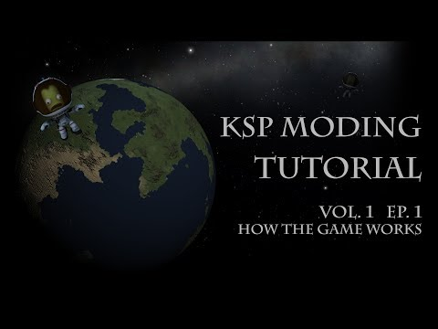](https://youtu.be/FypO9m-i6uw)https://youtu.be/FypO9m-i6uw](https://youtu.be/FypO9m-i6uw)

- This covers the very basics.

[Vol. 1 Ep. 2 - Game Models and Textures](https://www.youtube.com/watch?v=7hRJ1qI8uoY)

- This covers proper model and texture setup in Blender, setup and exporting through Unity, and even goes into setting up animations.

[[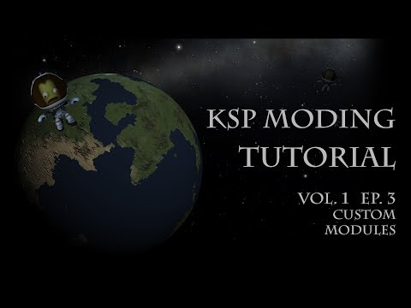](https://youtu.be/GxeZDvyT7UY)https://youtu.be/GxeZDvyT7UY](https://youtu.be/GxeZDvyT7UY)

and

[[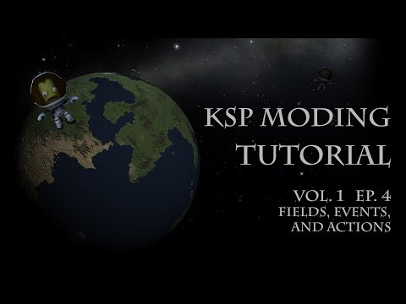](https://youtu.be/R90SejwrqVY)https://youtu.be/R90SejwrqVY](https://youtu.be/R90SejwrqVY)

- These two cover things on the programming side: modules, plugins, .dlls, etc.

[[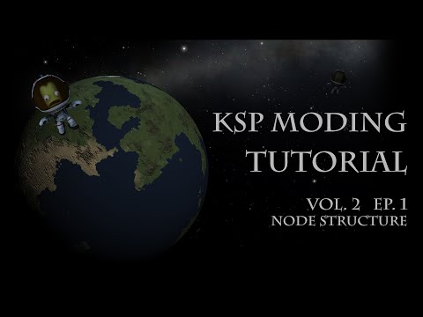](https://youtu.be/XqrOVKEj2i0)https://youtu.be/XqrOVKEj2i0](https://youtu.be/XqrOVKEj2i0)

- How KSP saves and loads its data, from part configs, to ship designs, to entire game saves.

Tutorials by nli2work

[Discussion thread](https://forum.kerbalspaceprogram.com/threads/94871)

for the following tutorials.

[[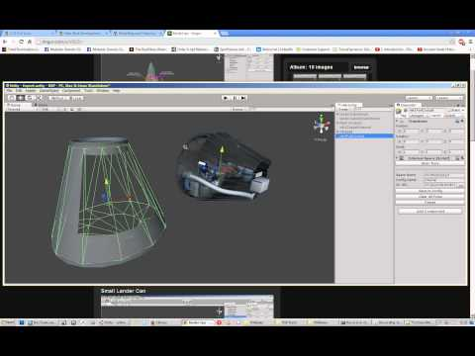](https://youtu.be/ux_9tO6PShA)https://youtu.be/ux\_9tO6PShA](https://youtu.be/ux_9tO6PShA)

- Exterior/Interior Unity setup; export to KSP; slight config error near the end. ~1hr

[[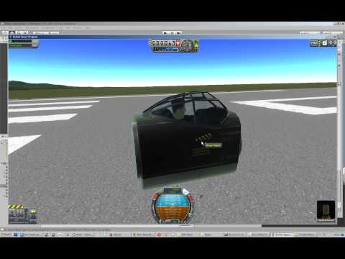](https://youtu.be/m8C2-A3qsLk)https://youtu.be/m8C2-A3qsLk](https://youtu.be/m8C2-A3qsLk)

- Error corrected and explained; External/Internal basic function checks ~15min

[[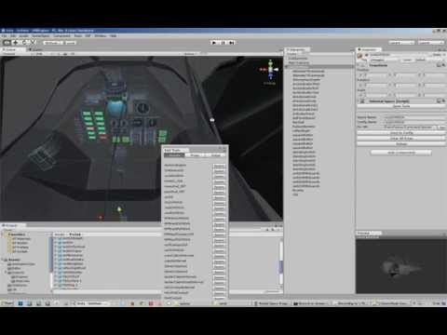](https://youtu.be/PrjTcv9WmRQ)https://youtu.be/PrjTcv9WmRQ](https://youtu.be/PrjTcv9WmRQ)

- Spawning IVA in Unity; populating IVA with Props and Light ~35m

[[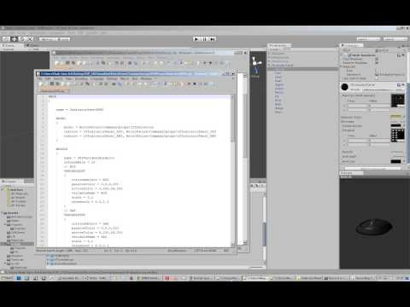](https://youtu.be/j-9sNqmnnpA)https://youtu.be/j-9sNqmnnpA](https://youtu.be/j-9sNqmnnpA)

- Internal Props; ~16min

[[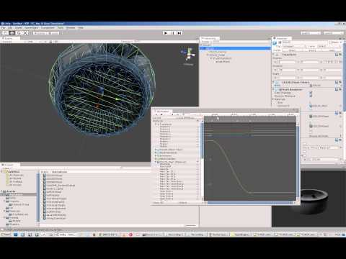](https://youtu.be/RPt0bMtj8Yc)https://youtu.be/RPt0bMtj8Yc](https://youtu.be/RPt0bMtj8Yc)

- Basic Engine setup; with Emissive, Gimbal, and Fairing

[[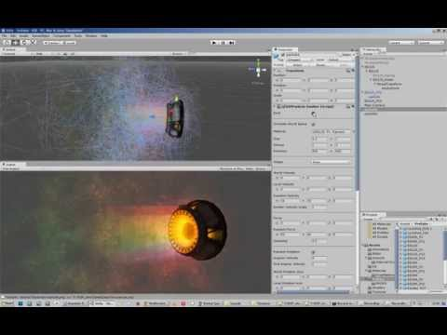](https://youtu.be/0mArVHil_ek)https://youtu.be/0mArVHil\_ek](https://youtu.be/0mArVHil_ek)

- Engine setup with EFFECT{}

Plugin Tutorials by Cybutek

[[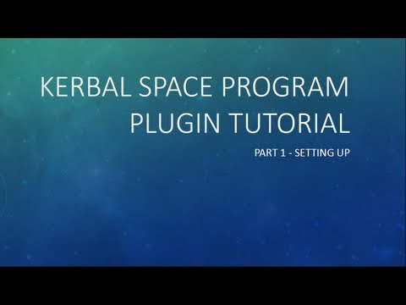](https://youtu.be/ilWZjYx7brE)https://youtu.be/ilWZjYx7brE](https://youtu.be/ilWZjYx7brE)

[[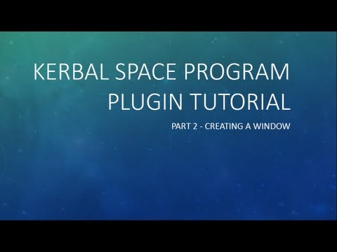](https://youtu.be/b-rwQRKz0PM)https://youtu.be/b-rwQRKz0PM](https://youtu.be/b-rwQRKz0PM)

[[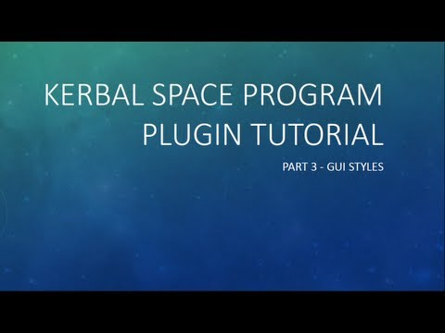](https://youtu.be/WpgWnDgwNhM)https://youtu.be/WpgWnDgwNhM](https://youtu.be/WpgWnDgwNhM)

[[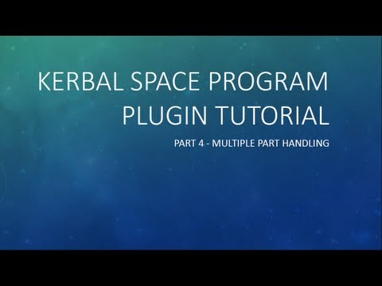](https://youtu.be/LJZzkEibn8M)https://youtu.be/LJZzkEibn8M](https://youtu.be/LJZzkEibn8M)

[[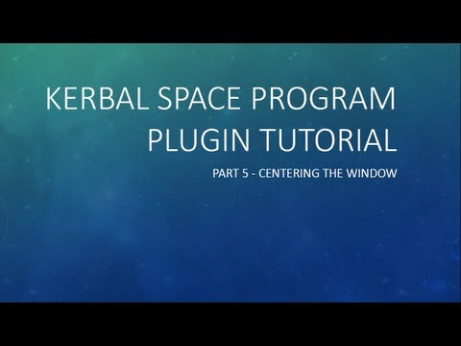](https://youtu.be/L7CyUL03ssU)https://youtu.be/L7CyUL03ssU](https://youtu.be/L7CyUL03ssU)

[[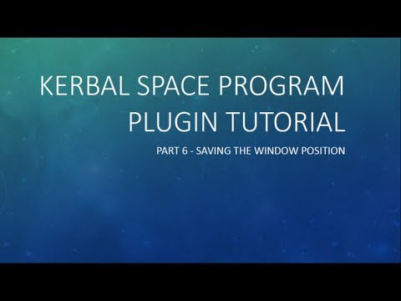](https://youtu.be/_qruuunMpHA)https://youtu.be/\_qruuunMpHA](https://youtu.be/_qruuunMpHA)

[[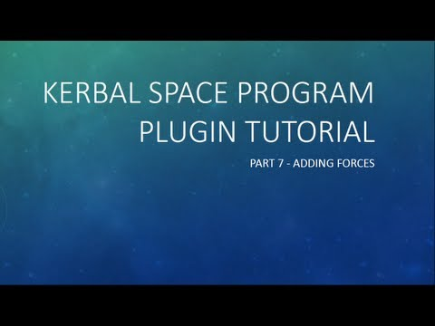](https://youtu.be/zHKZPLDdz6k)https://youtu.be/zHKZPLDdz6k](https://youtu.be/zHKZPLDdz6k)

**TEXT TUTORIALS**

[Making a simple engine in Wings 3D, from start to finish.](https://forum.kerbalspaceprogram.com/entries/3232)

**MISCELLANEOUS**

[Official Unity tutorials](https://unity3d.com/learn)

[Unity Layers and Tags](https://forum.kerbalspaceprogram.com/threads/93417)

[KSP floatCurves guide](https://forum.kerbalspaceprogram.com/threads/93332) - Important for many Part Modules **Important**

[A snippet on ISP and fuel density](https://forum.kerbalspaceprogram.com/threads/25157)

[Creating a new resource](https://forum.kerbalspaceprogram.com/threads/28168?p=345289&viewfull=1#post345289)

[Stock Parts Costs and Balance Spreadsheet for 0.24](https://forum.kerbalspaceprogram.com/threads/86406)

[FlagDecal, Docking port IDs, PNG Unity import bug](https://forum.kerbalspaceprogram.com/threads/35225)

[Unofficial 0.25 modding info](https://forum.kerbalspaceprogram.com/threads/95874)

**UNITY/CONFIGS**

Getting started

[Unity to KSP: A Detail Tutorial](https://forum.kerbalspaceprogram.com/threads/25040) - written by Kerbtrek

[Part Tools 0.20, Blender, Unity and KSP](https://forum.kerbalspaceprogram.com/threads/40178) - written by Cheebsta

[Example Config file for loading a .Mu file into the game](https://forum.kerbalspaceprogram.com/threads/25013?p=642248&viewfull=1#post642248) - written by Tiberion

[TUTORIAL: Getting Started With Unity](https://forum.kerbalspaceprogram.com/threads/25482) - written by Nutt007, includes a video for 0.15

[Tutorial:Making and asset from start to finish](http://wiki.kerbalspaceprogram.com/wiki/Tutorial:Making_an_asset_from_start_to_finish)

Air Intakes

[Intakes for jet engines](https://forum.kerbalspaceprogram.com/threads/24988)

[Intake area explanation](https://bitbucket.org/Taverius/b9-aerospace/wiki/Intake%20Area.md?_escaped_fragment_=intake-area#%21intake-area)

Airlock (Actually a hatch, but it's called an airlock in KSP)

[Adding airlocks and ladders to parts](http://wiki.kerbalspaceprogram.com/wiki/Adding_Airlocks_and_Ladders_to_Parts) - Airlock collider must extend beyond the ladder collider to allow the click menu.

[Airlock positioning 1](https://forum.kerbalspaceprogram.com/threads/94345)

[Airlock positioning 2](https://forum.kerbalspaceprogram.com/threads/46606?p=606748&viewfull=1#post606748)

[Airlock positioning 3](https://forum.kerbalspaceprogram.com/threads/80614?p=1170828&viewfull=1#post1170828)

Animation

[Blender to Unity animation tutorial](https://forum.kerbalspaceprogram.com/threads/27450?p=346176&viewfull=1#post346176) - written by Xellith

[Exporting an Animation from Blender](https://forum.kerbalspaceprogram.com/threads/27450?p=336248&viewfull=1#post336248)

[Looped animation](https://forum.kerbalspaceprogram.com/threads/25476)

[Anim Switch details for repeating animation in reverse](https://forum.kerbalspaceprogram.com/threads/59106-Anim-Switch?p=809129&viewfull=1#post809129)

[Repeating animation in reverse](https://forum.kerbalspaceprogram.com/threads/25135?p=551627&viewfull=1#post551627) - Old

[Start point in animation for VAB snippet](https://forum.kerbalspaceprogram.com/threads/25135?p=307897&viewfull=1#post307897)

Attach nodes (Radial attachment)

[Transform-based NODE{}](https://forum.kerbalspaceprogram.com/threads/95336?p=1450592&viewfull=1#post1450592) - New better way. Requires [srFix](https://forum.kerbalspaceprogram.com/threads/96100)

.[Radial attach coordinates](https://forum.kerbalspaceprogram.com/threads/58902?p=798612#post798612) - Old way

[Tweaking attach nodes snippets](https://forum.kerbalspaceprogram.com/threads/25372) - Old way

Collision meshes

[Collision Mesh snippets](https://forum.kerbalspaceprogram.com/threads/24591)

[Normal mesh use](https://forum.kerbalspaceprogram.com/threads/25040?p=307884&viewfull=1#post307884)

[Exploding Kerbals](https://forum.kerbalspaceprogram.com/threads/25648?p=313315&viewfull=1#post313315)

Cargo Bays

[NoAttach tag](https://forum.kerbalspaceprogram.com/threads/98340) - Prevents surface attachment for specific colliders.

Contract Testing

[ModuleTestSubject](https://forum.kerbalspaceprogram.com/threads/92710)

Control Surfaces

[Creating a control surface](https://forum.kerbalspaceprogram.com/threads/48327?p=626740&viewfull=1#post626740)

Decouplers

[Decoupler modules](https://forum.kerbalspaceprogram.com/threads/25013?p=457260&posted=1#post457260)

Docking Ports

[Adding a docking node in Unity](https://forum.kerbalspaceprogram.com/threads/24569)

[Stock Docking Port in Unity](https://www.imgur.com/vtiTP.png) - Image

[Docking port IDs](https://forum.kerbalspaceprogram.com/threads/35225?p=443161&viewfull=1#post443161)

["Control from here" for docking ports](https://forum.kerbalspaceprogram.com/threads/94742) - Useful if your part alignment is different from your docking port direction.

Emissive textures

[Emissive tutorial - new thread](https://forum.kerbalspaceprogram.com/threads/25023) - written by CardBoardBoxProcessor

[Emissive tutorial - old thread](https://forum.kerbalspaceprogram.com/threads/11806) - written by CardBoardBoxProcessor

[Setting up an emissive on a light](https://forum.kerbalspaceprogram.com/threads/35778?p=450883&viewfull=1#post450883) - Big pictures

[Stopping toggleable emissives showing up lit in VAB/SPH thumbnails](https://forum.kerbalspaceprogram.com/threads/35778?p=453113&viewfull=1#post453113)

[Looping an emissive](https://forum.kerbalspaceprogram.com/threads/34586?p=443395&viewfull=1#post443395)

[Throttle-response emissive snippet](https://forum.kerbalspaceprogram.com/threads/25203?p=307981&viewfull=1#post307981)

[If you have problems with the latest Unity version](https://forum.kerbalspaceprogram.com/threads/25023?p=921862&viewfull=1#post921862)

Engines

**See Video Tutorials above first.**

[[HOWTO] Airbreathing Engines in KSP 1.0](https://forum.kerbalspaceprogram.com/threads/120899)

[Quick how-to on setting up a thrustTransform for an Engine](https://forum.kerbalspaceprogram.com/threads/24878)

[Snippet on thrustTransforms](https://forum.kerbalspaceprogram.com/threads/26371?p=322733&viewfull=1#post322733)

[Unity hierarchy for Gimballing nozzles](https://forum.kerbalspaceprogram.com/threads/28816?p=355601&viewfull=1#post355601)

[ModuleGimbal and ModuleJettison](https://forum.kerbalspaceprogram.com/threads/96024?p=1463159&viewfull=1#post1463159) - config settings.

[Trouble shooting why an engine might not work](https://forum.kerbalspaceprogram.com/threads/48142)

[Multiple nozzles](https://forum.kerbalspaceprogram.com/threads/48222?p=625485&viewfull=1#post625485)

[Example](https://forum.kerbalspaceprogram.com/threads/96024?p=1464513&viewfull=1#post1464513) - Unity package and compiled part with config.

Engine Fairings

**See Video Tutorials above first.**

To make fairings in VAB/SPH thumbnail invisible, set the fairing objects tag to Icon\_Hidden. You will need to create a new tag to do this.

[Example image of the tag](https://i.imgur.com/tYnWRqi.png)

[Removing the fairings from stock engines](https://forum.kerbalspaceprogram.com/threads/48489?p=630586&viewfull=1#post630586)

**See above for an example engine.**

Flag Decal

[Flag decal module](https://forum.kerbalspaceprogram.com/threads/35225?p=443161&viewfull=1#post443161)

[Positioning the decal](https://forum.kerbalspaceprogram.com/threads/93968?p=1492916&viewfull=1#post1492916)

GameDatabase

[0.20+ specific config extras](https://forum.kerbalspaceprogram.com/threads/34013?p=423632&viewfull=1#post423632)

IVA

**See Video Tutorials above first.**

[IVA Tutorial](https://forum.kerbalspaceprogram.com/threads/45070) - written by TouhouTorpedo - old?

[0.17 IVA tutorial](https://forum.kerbalspaceprogram.com/threads/23030) - I have no idea if this is still relevant, I've not tried to do any IVA's

[Alternate camera for IVA portraits](https://forum.kerbalspaceprogram.com/threads/70868)

[Stock IVA orientation reference](https://forum.kerbalspaceprogram.com/threads/25013?p=1219377&viewfull=1#post1219377)

Ladders

[Adding airlocks and ladders to parts](http://wiki.kerbalspaceprogram.com/wiki/Adding_Airlocks_and_Ladders_to_Parts)

Landing gear

[Discussion of a WIP landing gear. Lots of useful information](https://forum.kerbalspaceprogram.com/threads/72802)

[Stock Landing Gear in Unity](https://www.imgur.com/i1aPm.png) - Image

[Landing gear snippets](https://forum.kerbalspaceprogram.com/threads/24738) - Spread out through the thread

Landing legs

[Animated Landing leg w/ suspension tutorial](https://forum.kerbalspaceprogram.com/threads/77991)

[0.22 Landing Leg module in Unity](https://i.imgur.com/kKMEbtk.png) - Image

Launch stability enhancer / Launch tower

[Launch Clamp How-To (Tutorial)](https://forum.kerbalspaceprogram.com/index.php?/topic/139076-launch-clamp-how-to-tutorial)

[FASA Launch Tower tutorial](https://forum.kerbalspaceprogram.com/threads/76136)

Lights

[Some tips for setting up lights](https://forum.kerbalspaceprogram.com/threads/47009?p=612658&viewfull=1#post612658)

Model definition

[Replacing "mesh" with "MODEL{}"](https://forum.kerbalspaceprogram.com/threads/62918)

[Scaling attach nodes with MODEL{}](https://forum.kerbalspaceprogram.com/threads/57690?p=771404&viewfull=1#post771404)

Parachutes

[Stock Parachute in Unity](https://i.imgur.com/h4T5MBC.png) - Image

[Components of a parachute](https://forum.kerbalspaceprogram.com/threads/57646?p=770729&viewfull=1#post770729)

RCS

[RCS Tutorial](https://forum.kerbalspaceprogram.com/threads/98373)

Rover wheels

[Wheel rigging, setup and fault finding](https://forum.kerbalspaceprogram.com/threads/95652) - Video tutorial.

[Guide with Unity scene example](https://forum.kerbalspaceprogram.com/threads/83200)

[Stock Rover Wheel in Unity](https://i.imgur.com/XHZoV2G.png) - Image

[Changing wheel torque](https://forum.kerbalspaceprogram.com/threads/27131)

Science

[Science and mods!](https://forum.kerbalspaceprogram.com/threads/53025)

Solar Panels

[Stock Folding Solar Panels in Unity](https://i.imgur.com/lUZf3C0.png)- Image

[Setting up suntracking solar panels](https://forum.kerbalspaceprogram.com/threads/38408)

[Powercurve explanation](https://forum.kerbalspaceprogram.com/threads/38408?p=490565&viewfull=1#post490565)

Sounds

[Using EFFECTS nodes to play custom sounds](https://forum.kerbalspaceprogram.com/threads/25013?p=919658&viewfull=1#post919658)

[How to get custom sounds to play without a plugin](https://forum.kerbalspaceprogram.com/threads/25013?p=719252&viewfull=1#post719252) - Pre-0.23 info

Stack nodes

[Transform-based NODE{}](https://forum.kerbalspaceprogram.com/threads/95336?p=1450592&viewfull=1#post1450592) - Allows you to easily add nodes with transforms. Makes angled nodes easier to implement.

Temperature

[Quick guide to temperature rules](https://forum.kerbalspaceprogram.com/threads/117930)

Textures and Shaders

[Adding a normal map](https://forum.kerbalspaceprogram.com/threads/25010)

[Faking detail with a normal map](https://forum.kerbalspaceprogram.com/threads/24677?p=314423&viewfull=1#post314423)

[Fixing unwanted texture transparency](https://forum.kerbalspaceprogram.com/threads/25088?p=306853&viewfull=1#post306853)

[Unwanted transparent faces](https://forum.kerbalspaceprogram.com/threads/27901)

[Potential fixes for incorrect shading](https://forum.kerbalspaceprogram.com/threads/36212?p=456665&viewfull=1#post456665)

[PNG versus TGA loading time](https://forum.kerbalspaceprogram.com/threads/25241?p=516773#post516773)

Welding

[Example of using 0.20+ MODEL{} modules to combine parts](https://forum.kerbalspaceprogram.com/threads/34013?p=454874&viewfull=1#post454874)

[MODEL{} tutorial - Learn How to Weld!](https://forum.kerbalspaceprogram.com/entries/829) - written by johnsonwax - GONE!

[MODEL{} tutorial - Intermediate Welding and Part Scaling](https://forum.kerbalspaceprogram.com/entries/833) - written by johnsonwax

Wings

[Wing creation mini tutorial](https://forum.kerbalspaceprogram.com/threads/90864)

**ADDONS FOR MODDERS**

These addons extend the functionality available for mod creators and help with mod development

Tools

[DevHelper](https://forum.kerbalspaceprogram.com/threads/60880) - Bypass main menu to automatically load any saved game

[LoadOnDemand](https://forum.kerbalspaceprogram.com/threads/73236) - **Important.** Loads textures as needed, reducing the memory footprint and speeding up load times without loss of quality. Not actively developed but community fix is available.

[ModuleMirror](https://forum.kerbalspaceprogram.com/threads/90543) - Mirror symmetry for asymmetrical parts

[Part Icon Fixer & Tweaks](https://forum.kerbalspaceprogram.com/threads/101632) - Rescales part icons in the VAB and SPH to more appropriate sizes.

[RCS Build Aid](https://forum.kerbalspaceprogram.com/index.php?/topic/33124-1) - Provides visual clues about ship movement under thrust from RCS or engines. Great for if you're making replica ships

[srFix](https://forum.kerbalspaceprogram.com/threads/96100) - **Important.**A fix for the currently non-functioning NODE{} HINGE\_JOINTs.

Mods

[Adaptive Docking Node](https://forum.kerbalspaceprogram.com/threads/79128) - Create non-androgynous docking ports or ones that attach to more than one port size/type.

[BDArmoury](https://forum.kerbalspaceprogram.com/threads/85209) - Includes a .50 cal turret unity package as an example if you want to make your own weapons

[Community Resource Pack](https://forum.kerbalspaceprogram.com/threads/91998) - Community-defined resources. Check in here before defining a new resource.

[Connected Living Space](https://forum.kerbalspaceprogram.com/threads/70161) / [Config How-To](https://github.com/codepoetpbowden/ConnectedLivingSpace/blob/master/CLS%20Config%20HOWTO.txt) - API for inhabitable areas and passable/impassable parts.

[DMagic Module Science Animate](https://forum.kerbalspaceprogram.com/threads/72466) - versatile plugin for science experiments

[Ferram Aerospace Research](https://forum.kerbalspaceprogram.com/threads/20451) / [Deriving FAR values for a wing using Blender](https://github.com/ferram4/Ferram-Aerospace-Research/wiki/Deriving-FAR-values-for-a-wing-using-Blender-2.7)

[Firespitter](https://forum.kerbalspaceprogram.com/threads/24551) / [Firespitter Module Documentation](https://docs.google.com/document/d/1iD52DfHft04Hb48TEhF5a4n5JOc8efUevdg5Y_QPICQ/edit" \t "_blank) - various aircraft-related modules as lots of others.

[HotRockets!](https://forum.kerbalspaceprogram.com/threads/65754) - Particle FX Replacement

[Infernal Robotics](https://forum.kerbalspaceprogram.com/threads/37707) / [How to make robotic parts](https://forum.kerbalspaceprogram.com/threads/81568) - Create controllable robotic parts that rotate or translate.

[JSIPartUtilities](https://forum.kerbalspaceprogram.com/threads/88366) - Let's you toggle meshes and colliders on and off, and other things

[Kerbaloons](https://forum.kerbalspaceprogram.com/threads/119297) / [How to make your own balloon part using KerBalloons](https://forum.kerbalspaceprogram.com/threads/136938) - Create baloons

[Kethane](https://github.com/Majiir/Kethane/wiki/API-and-Modules-Documentation) - Majir restricts the use of some modules

[Modular Fuel Tanks](https://forum.kerbalspaceprogram.com/threads/64117) - Create user-configurable resource tanks.

[Module Manager](https://forum.kerbalspaceprogram.com/threads/55219) - allows patching of configs at runtime without overwriting

[OpenParticleEmitter](https://forum.kerbalspaceprogram.com/threads/65364) - Kethane-derived alternate particles module. Source code only

[Open Resource System](https://forum.kerbalspaceprogram.com/threads/64595) - Karbonite (An open Kethane alternative) uses this. Also see

[Community Resource Pack](https://forum.kerbalspaceprogram.com/threads/91998)

[Raster Prop Monitor](https://github.com/Mihara/RasterPropMonitor/wiki) - Configure aircraft and spaceship monitors in IVA

[Real Fuels](https://forum.kerbalspaceprogram.com/threads/64118) - Makes resources and their measurements based on real science.

[SmokeScreen](https://forum.kerbalspaceprogram.com/threads/71630) - Extended FX plugin

[Texture Animation Util](https://forum.kerbalspaceprogram.com/threads/97751) - Scrolls textures on a mesh randomly or smoothly.

[Toolbar](https://forum.kerbalspaceprogram.com/threads/60066)- Add a visible toollbar button to your plugin

**PLUGIN DEVELOPMENT**

I would love someone with Plugin experience to point out helpful threads for this

[Add-on Posting Rules](https://forum.kerbalspaceprogram.com/threads/87843)

[CompatibilityChecker](https://forum.kerbalspaceprogram.com/threads/65395) - Source code for plugin authors to implement a checker that shows a message if their mod is incompatible with the user's version of KSP and/or Unity

[KSP API Documentation](https://anatid.github.io/XML-Documentation-for-the-KSP-API/index.html)

[Official PartModule Documentation](https://forum.kerbalspaceprogram.com/threads/92643)

[Starting out on Plugins](https://forum.kerbalspaceprogram.com/threads/25578?p=312392&viewfull=1#post312392)

[KSP Plugin Framework - Plugin Examples and Structure](https://forum.kerbalspaceprogram.com/threads/66503) - by TriggerAu, very recent and up to date

[Example plugin projects to help you get started](https://forum.kerbalspaceprogram.com/threads/56053) - by TaranisElsu

[The official unoffical help a fellow plugin developer thread](https://forum.kerbalspaceprogram.com/threads/7544)

[Wiki page on Plugins](http://wiki.kerbalspaceprogram.com/wiki/Plugins)

[Creating your first module](http://wiki.kerbalspaceprogram.com/wiki/Creating_your_first_module) - on the Wiki

[Info on spawning objects and applying gravity](https://forum.kerbalspaceprogram.com/threads/104252) - Includes example code, links to more examples, and some useful hints.

[How to animate a part with multiple animations?](https://forum.kerbalspaceprogram.com/threads/128481)

[Great info on Kerbal transforms, bones, rig, FSM, states (ragdoll, idle, sumble, run etc)](https://forum.kerbalspaceprogram.com/threads/127278)

Some really good info on writing Unity CG shaders. Even if you're not going to write a custom shader yourself, it still gives you a great insight into what the various bits of the KSP shaders actually control and output.

[[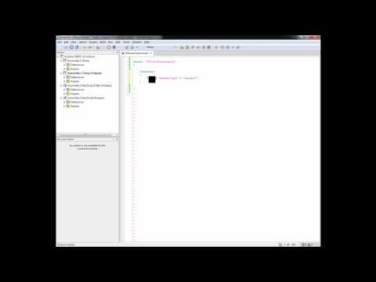](https://youtu.be/-IEjJpyPe7I)https://youtu.be/-IEjJpyPe7I](https://youtu.be/-IEjJpyPe7I)

[[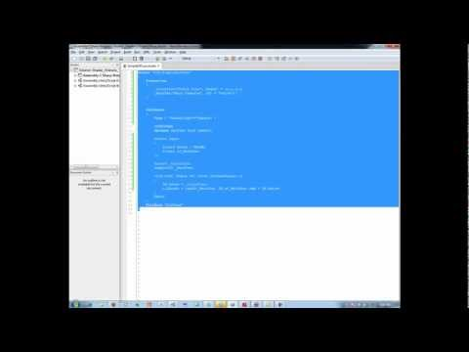](https://youtu.be/2eeUDNPjpO8)https://youtu.be/2eeUDNPjpO8](https://youtu.be/2eeUDNPjpO8)

[[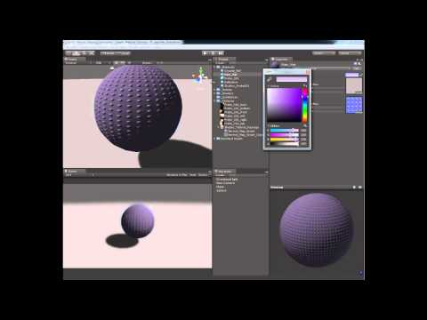](https://youtu.be/Lnhc2LJo434)https://youtu.be/Lnhc2LJo434](https://youtu.be/Lnhc2LJo434)

[[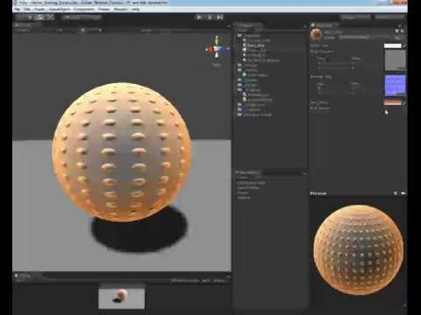](https://youtu.be/ajyJGyC34ZE)https://youtu.be/ajyJGyC34ZE](https://youtu.be/ajyJGyC34ZE)

[[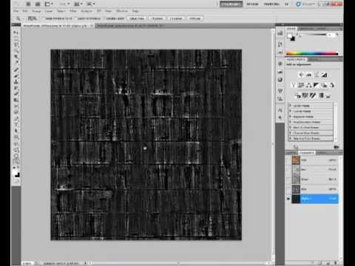](https://youtu.be/Tn679djIuI0)https://youtu.be/Tn679djIuI0](https://youtu.be/Tn679djIuI0)

[Info on loading and using custom shaders into KSP](https://forum.kerbalspaceprogram.com/threads/48840-HOW-TO-Using-custom-CG-shaders-in-KSP)

Misc Plugin Information

[Kethane Code Snippet](https://forum.kerbalspaceprogram.com/threads/65395?p=899895&viewfull=1#post899895) for an [incorrect installation warning](http://i4.minus.com/ibmfHR4W4LzlMg.png). Public domain license.

**Edited September 5, 2016 by CaptainKipard**  
Update